

Project Development Phase Delivery of Sprint-2

|  |  |
| --- | --- |
| **Date** | 07.11.2022 |
| **Team Id** | PNT2022TMID33764 |
| **Project Name** | AI Based Discourse for Banking Industry |

Types of account offered by the bank:

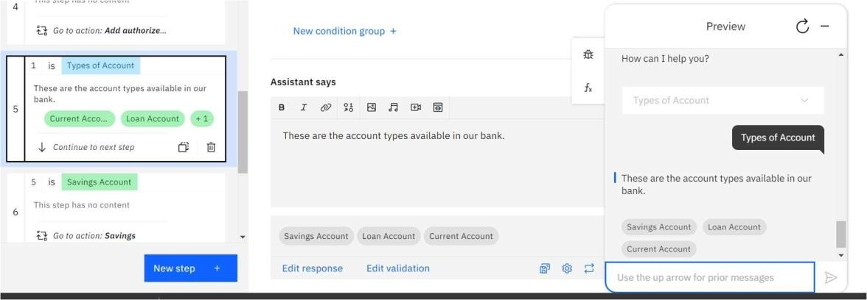

Files Required to create the account:

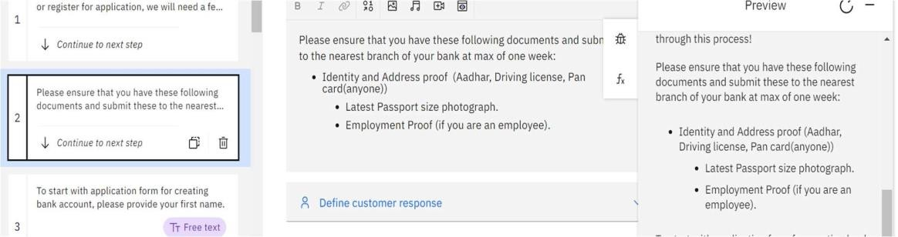



Status of loan:

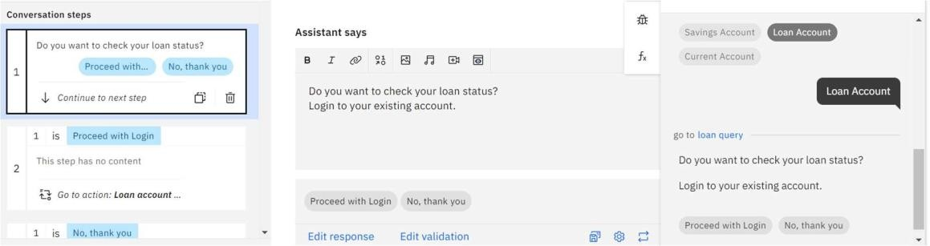

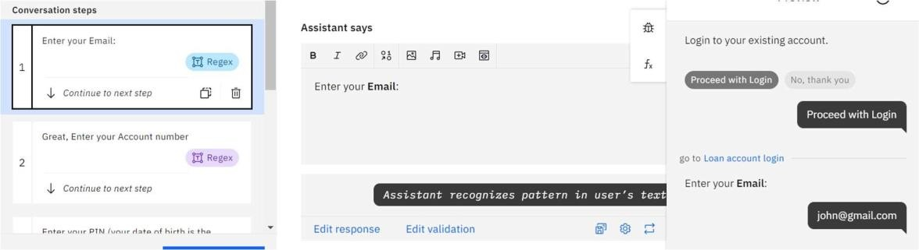

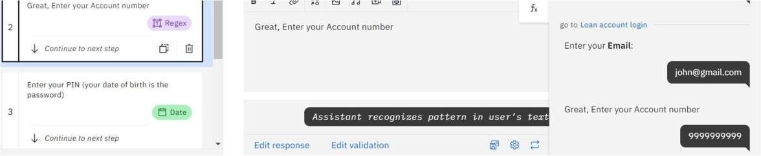

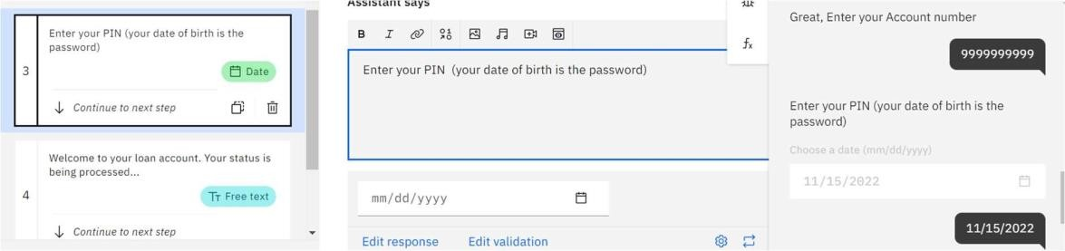



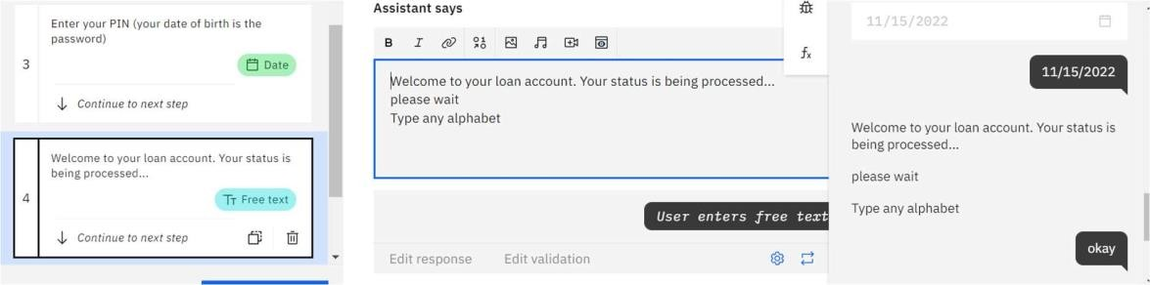

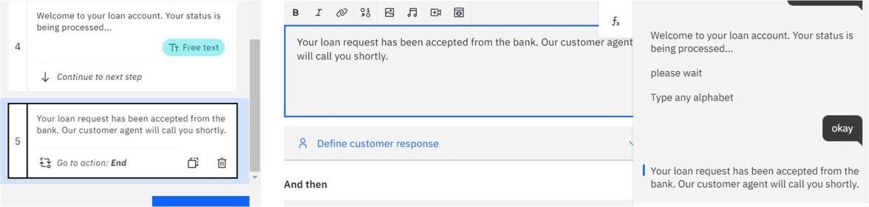

Loan Account Action:

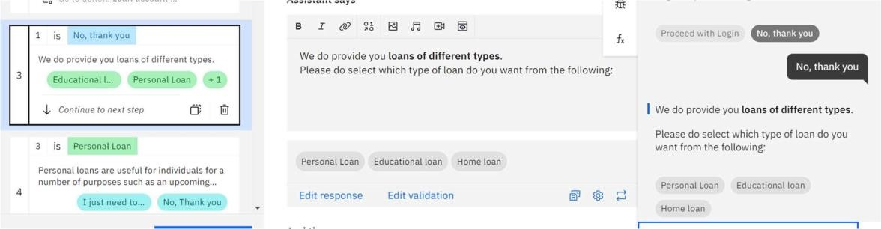

Personal Loan:

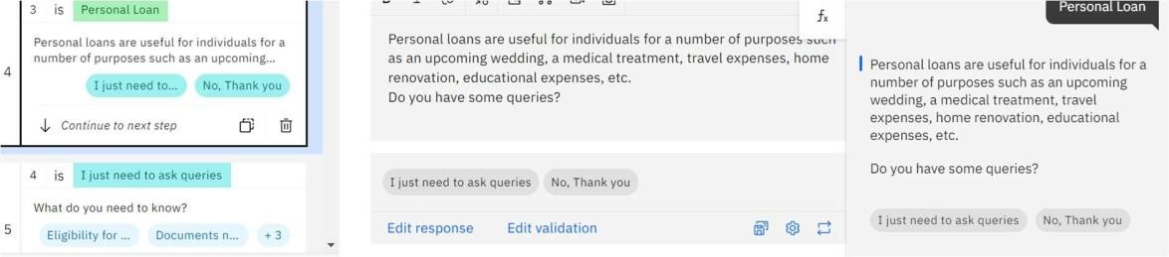



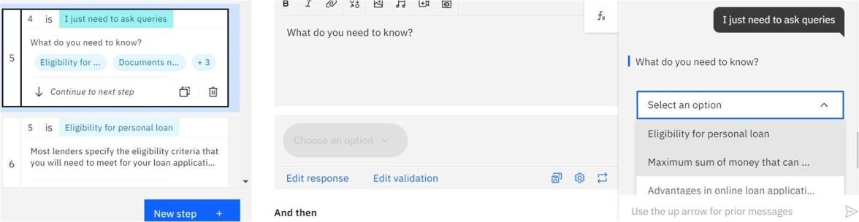

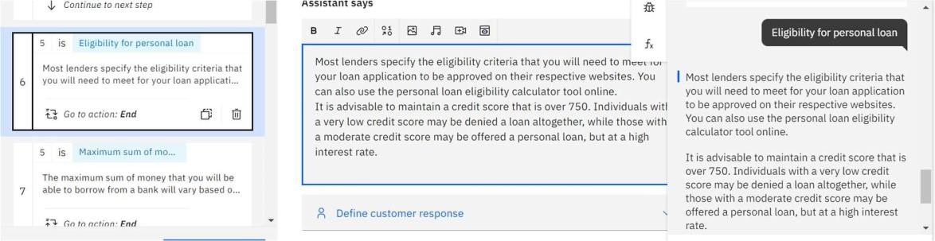

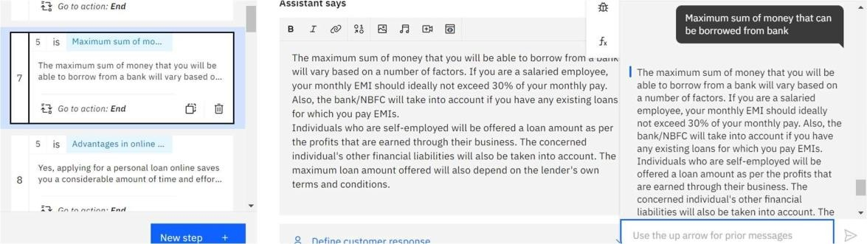

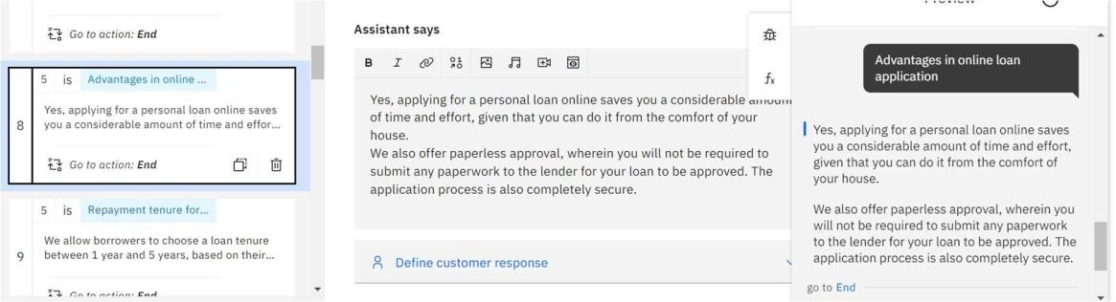



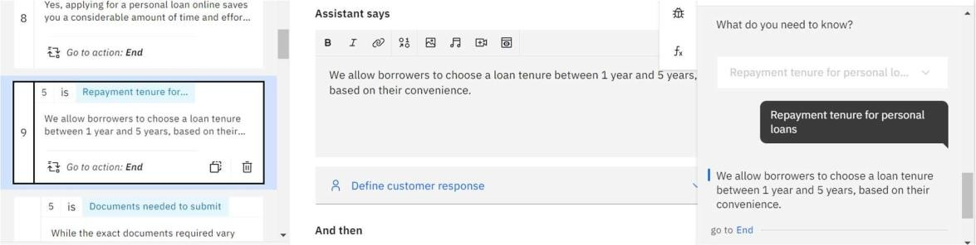

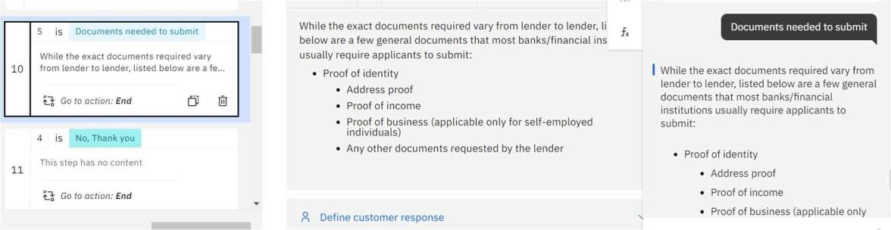

Educational loan

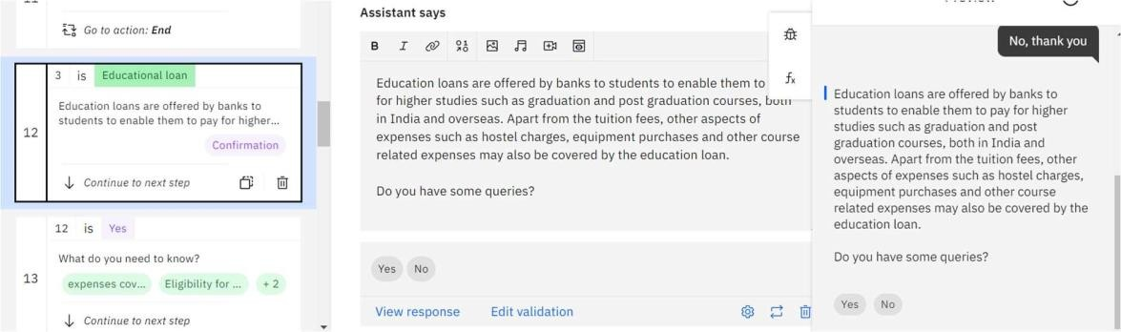

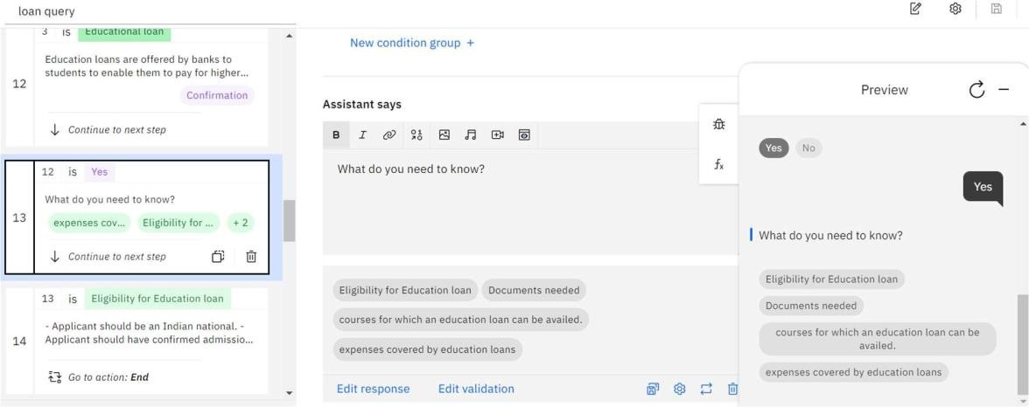



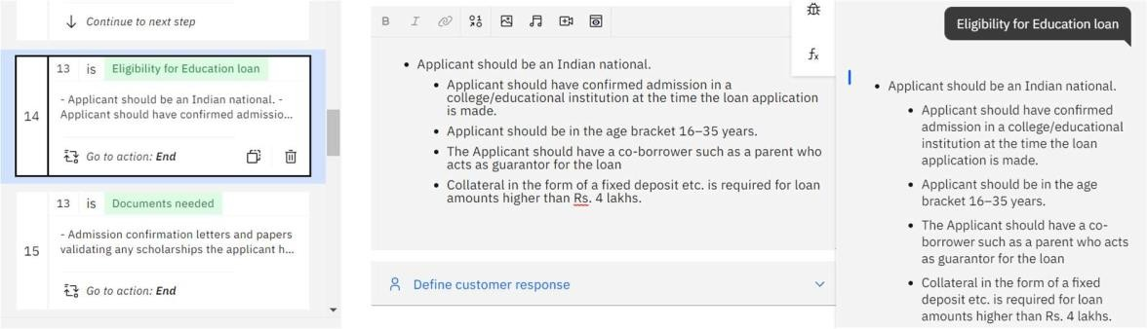

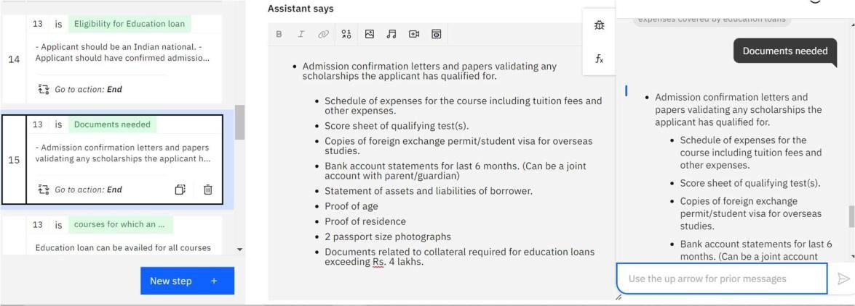

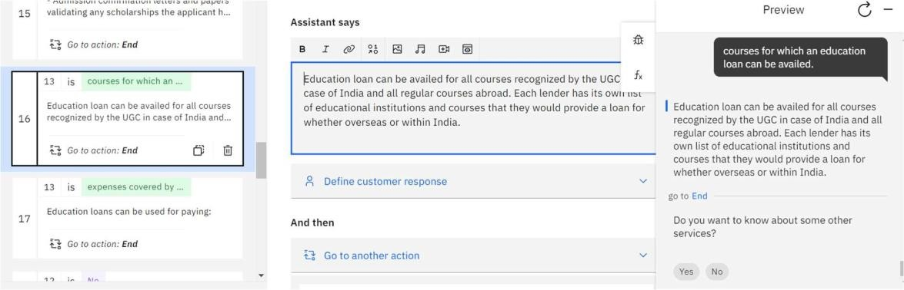

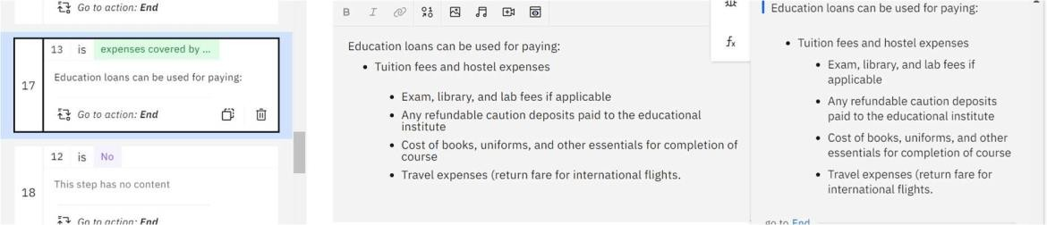



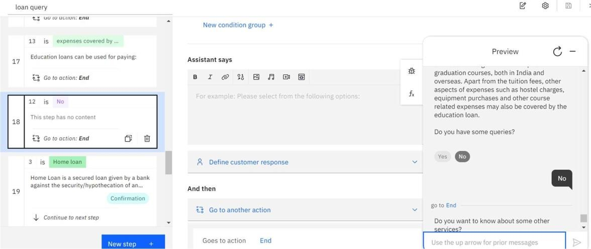

Home Loan

